GIT BRANCHING STRATEGIES:

1. Feature.
2. Release.
3. Tags.
4. Master.

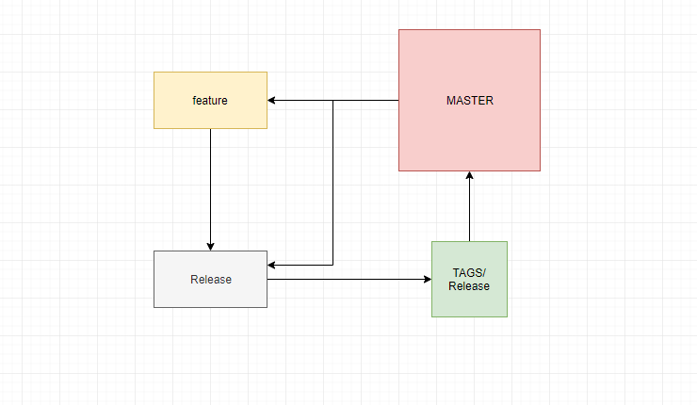

1. Feature Branch: For the sprint purpose created from Master Branch. It is used for any code changes.
2. Release Branch: Release Branch created from Master to get latest code. Next feature branch is merged into the Release branch.
3. Tags: Tags are created to lock the state of the code. It will be having the latest code commit/ pointer and it is in detached Head state.
4. Master: Master branch is treated as the prodbaseline code level. Any new development starts from creating a feature branch from master. Master branch merge should happen only with the tags into master.

Code Merge or Conflicts:

1. Providing the git diff report to dev and the change ticket team to review.
2. Always diff should be with branch to branch/ tag to tag.

Git tags:

1. Feature branches are merged to release.
2. Create tags from release tags as best practice.
3. Tags are then push to origin.
4. Tags are then merged to master.

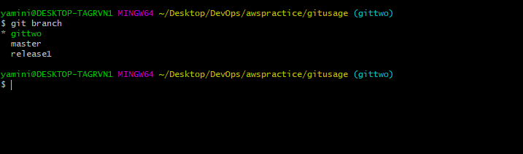

After creating release branches and creating a tag

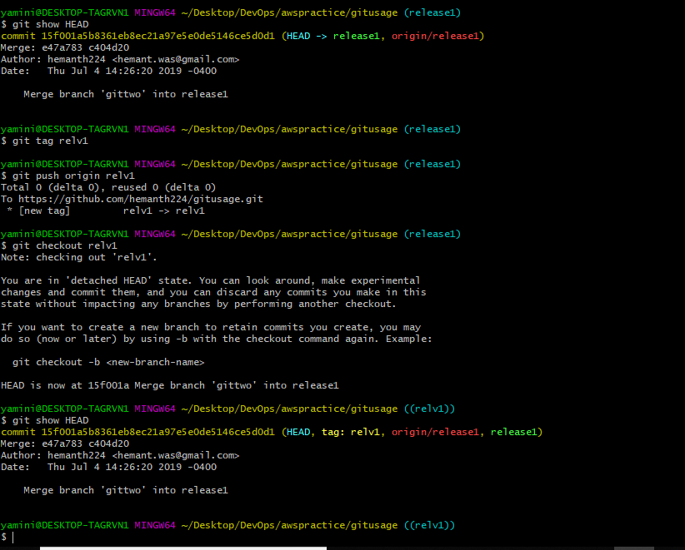

Final Stage:

1. Merging the tags into master and checking the latest commited TAG.

